## Collaboration Policy:

All work must be done in groups of 2 students. You are allowed to discuss the lab with other groups, and even help each other out. However, each group must complete their own lab and submit their own work.

## Submission info:

There are two types of “submissions” in this class.

Blue text denotes something that must be included in your lab writeup. Each lab has an associated writeup which must be submitted on Canvas before 11:59pm on the due date.

Red text denotes something that must be demoed (demonstrated) in person to a TA.

**Always confirm that a TA has checked you off before taking apart your lab.**

**Make sure you are using your assigned ESE519 Github accounts to submit your code**

**Please see the BOM** [**here**](https://drive.google.com/open?id=180ZI8SDMkudjMuMhvxh5_eAb938Xvvc4)**.**

Part 0

Due: Thurs 9/27 before labtime starts

Demo 0.2 and 0.3 to a TA during the first 10 minutes of labtime before moving onto Part 1

Part 1

Due: Thurs 9/27 before labtime starts

Demo 0.2 and 0.3 to a TA during the first 10 minutes of labtime before moving onto Part 1

Part 2

Due: Thurs 9/27 before labtime ends

Demo 1.1 and 1.2 to a TA before 7:29pm

Part 3

Due: Thurs 10/11 before labtime starts

Demo 2.1 and 2.2 to a TA during the first 10 minutes of labtime

Part 4

Due: Thurs 10/11 before labtime ends

Demo 3.1, 3.2 to a TA before 7:29pm

Writeup

Due: Thurs 10/11 on Canvas by 11:59pm

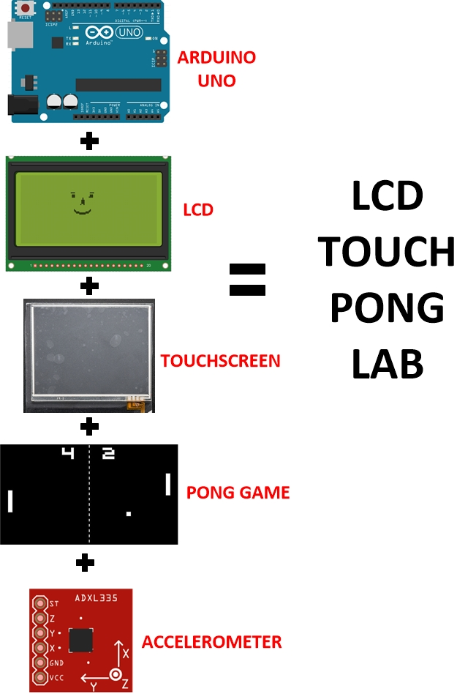

## Background

In this lab, you will learn the hardware, firmware and interfacing steps to make an interactive hand-held game. You will write a high-level driver for an LCD display to draw the game elements, interface it with a touchscreen and an IMU to make an interactive Pong game.

The lab will walk you through the process of making a working end-to-end embedded system through the following steps:

1. Interface an LCD with the Arduino Uno and write a high-level LCD driver to draw sprites
2. Interface a touchscreen with the Arduino Uno and calibrate it with respect to the LCD
3. Write a two-player Pong game given a specified criterion
4. Interface an IMU to control the Pong game and design a computer-player vs human-player version of the game

To get a better idea of what you will make, check out this video: <http://tinyurl.com/pong-lab>

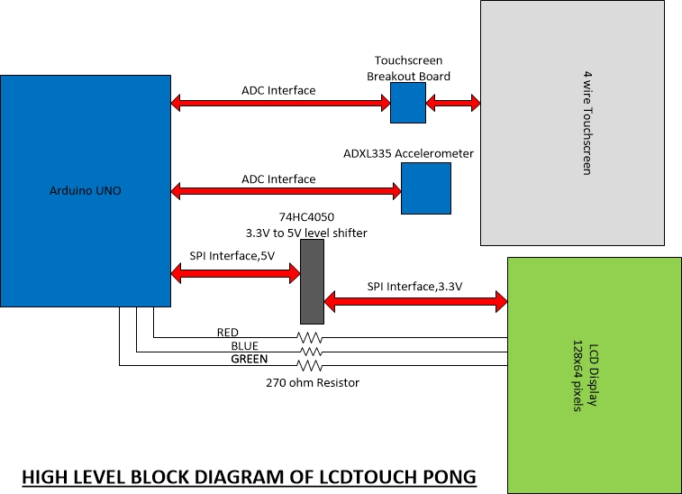

**Figure 1**: Block Diagram of LCD Touch Pong

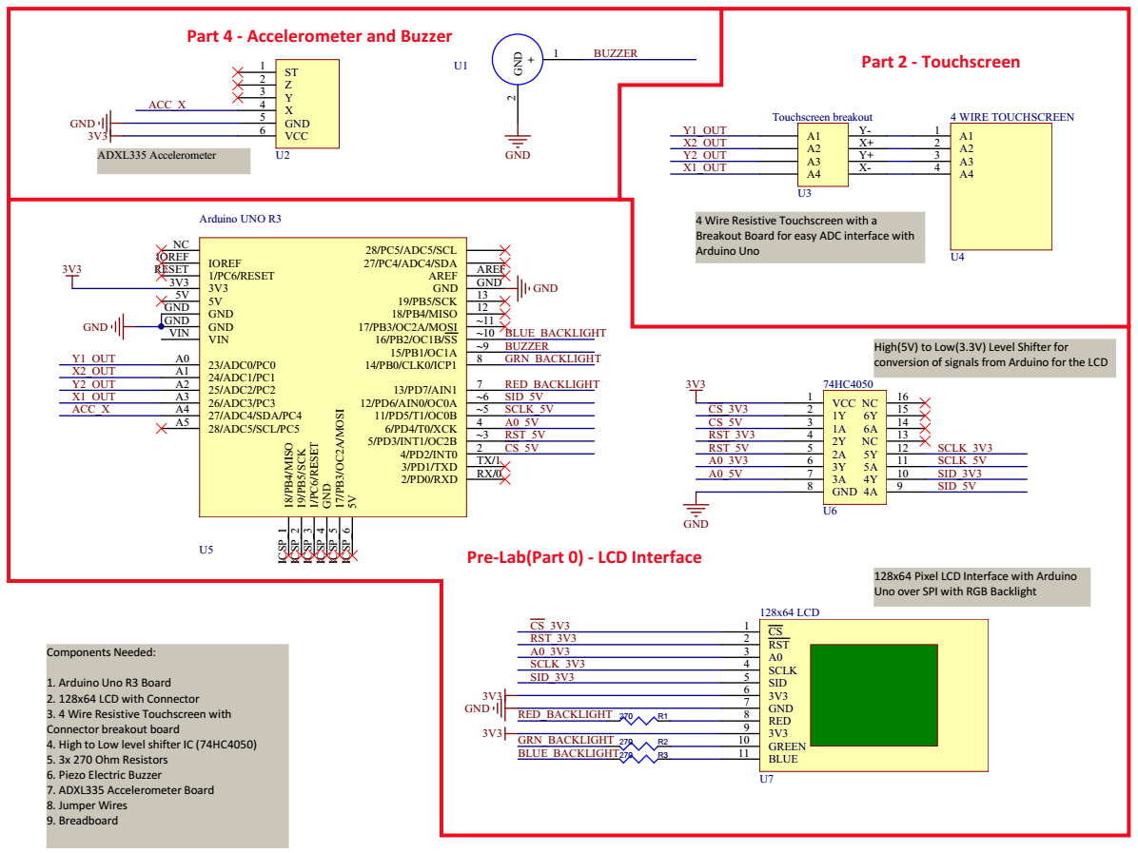

**Figure 2**: Overall Schematic Diagram for the complete TouchLCD Pong Lab

# 0.1: This LCD has way too many wires, but it could have been worse

## Objective

Your first task is to interface the LCD with the Arduino Uno. By the end of this lab you will be able to display an image on the LCD and be ready to program your graphics driver in the lab session.

## Deliverable

Complete circuit with all the LCD interfaces properly connected to the Arduino Uno. Download the provided HEX file to show the image on your LCD to your TA at the start of the lab session.

## Background

* The LCD is a graphical monochrome 128x64 pixel LCD with RGB LED backlight.
* It is powered by a 3.3V supply. As the Arduino has 5V i/o, we will need a High-to-Low level shifter to interface with the LCD.
* Unlike most LCDs of this technology which offer a parallel interface requiring lots of I/O, this LCD has a serial interface, using the Serial Peripheral Interface (SPI) bus.
* The LCD is write-only, so we cannot read the state from the LCD. Hence, we require a 128x64 = 1024 byte buffer allocated on the microcontroller. In the case of ATmega328p on Arduino Uno, this buffer will utilize half of the available 2K RAM.
* 5 pins are required to drive the LCD from a microcontroller in SPI mode. All of these pins are outputs from the microcontroller and inputs to the screen. Since it is not possible to read from the screen, there is no requirement for inputs.

## LCD Pinouts

The LCD has 11 exposed pins on a connector of 2mm pitch (meaning the spacing between each pin on the connector is 2mm).

1. **CSn - Chip select**
2. **RSTn - Reset**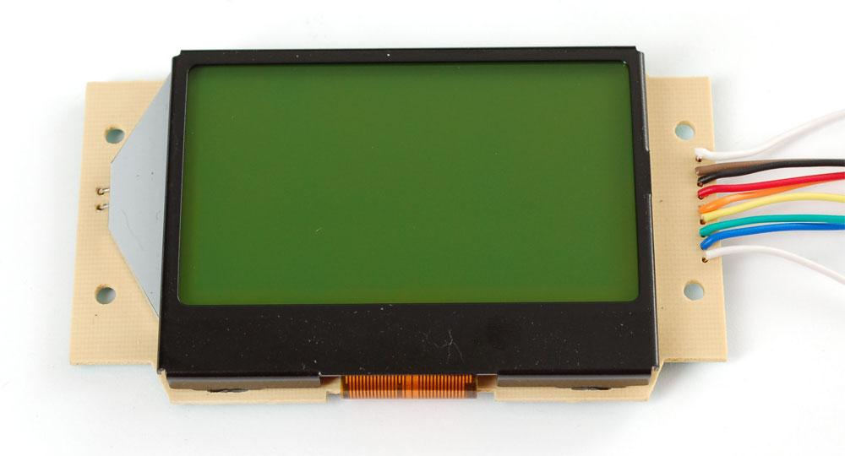
3. **A0/RS**
4. **SCLK – Serial Clock**
5. **SID – Serial Input Data**
6. VDD – 3.3V input
7. GND – Ground
8. R – Red Led cathode for backlight
9. 3.3 – 3.3V input to Led Anode for backlight
10. G – Green Led cathode for backlight
11. B – Blue Led cathode for backlight

From the pinouts, **CSn**, **RSTn**, **A0/RS**, **SCLK** and **SID** are the SPI interface pins at 3.3V.

R, G, B are the Red, Green , Blue LED backlight pins for the LCD.

## 

## High-to-Low level shifter

The Arduino Uno’s microcontroller Atmega328p runs at 5V, so the LCD pins cannot be directly interfaced with Arduino Uno pinouts. Thus we will utilize a circuit that will convert the high voltage 5V down to 3V. A [74HC4050](http://www.nxp.com/docs/en/data-sheet/74HC4050.pdf) high-to-low level shifter is used here to convert the high voltage of 5V down to 3.3V.

The following list details connections between the Arduino, IC, and LCD

The same information can also be found in the Overall Schematic Diagram (**Figure 1**)

SPI interface

* **3.3V** from Arduino to **pin1** of IC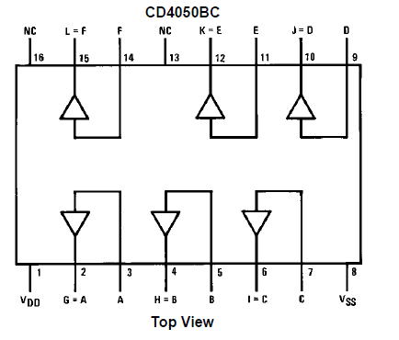
* **GND** from Arduino to **pin8** of IC
* **Digital 2** of Arduino to **pin 3** of IC
* **Digital 3** of Arduino to **pin 5** of IC
* **Digital 4** of Arduino to **pin 7** of IC
* **Digital 6** of Arduino to **pin 9** of IC
* **Digital 5** of Arduino to **pin 11** of IC
* **CSn** from LCD to **pin 2** of IC
* **RSTn** from LCD to **pin 4** of IC
* **A0** from LCD to **pin 6** of IC
* **SID** from LCD to **pin 10** of IC
* **SCLK** from LCD to **pin 12** of IC

We also need to connect the LCD backlight pins to the Uno. The specs are to connect them to 3.3 V through a 100 ohm resistor, but since all the Arduino logic pins are 5V and we are out of pins on the level shifter, we will connect the cathode of the backlight LEDs to 5V pins on Uno through a 270 ohm resistor.

So the backlight pins are connected via a 270 ohm resistor as follows:

* **R** from LCD to **Digital 7** of Arduino
* **G** from LCD to **Digital 8** of Arduino
* **B** from LCD to **Digital 10** of Arduino

# 0.1: Testing the LCD setup

Check if the LCD circuit works by flashing the provided hex file to the Arduino Uno and display the graphic on the screen.

1. Pull the hex file from github: <http://tinyurl.com/logos-test-hex>
2. Connect the Arduino Uno to the system.
3. Open command prompt and navigate to the location where hex file is downloaded
4. Type the following command (assuming Avrdude was downloaded from the link):

C:\avrdude\avrdude.exe -F -V -c arduino -p ATMEGA328P -P COM[n] -b 115200 -U flash:w:[hexfilename].hex:i

where [n] is your com port number and hexfilename is the name of the hex file.

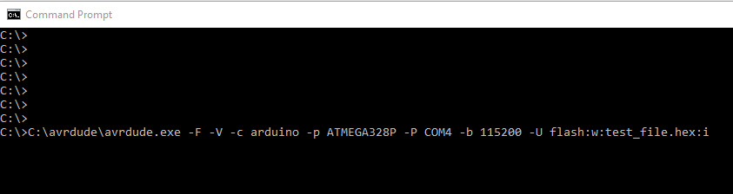

**Figure 5**: Example AVRdude command

1. If successful, avrdude will report that the flash was written. You should also see your Arduino's LED blink a few times.

Demo to TA before end of first lab

# 1.0: LCD High-level driver

## Objective

Write a high-level driver for the provided LCD based on the skeleton code provided to you.

1. Understand the basic functioning of LCD and how a pixel is accessible using bit banging
2. Write simple setpixel library function to print a pixel at an input coordinate on LCD
3. Write other LCD library function to draw lines, rectangles and other graphic functions required to make up the game

To get started all the LCD initialization functions and *drawchar* function have been provided in the skeleton code. You can pull code from [here](https://github.com/PennESE350/s2018).

## Functions to implement

* *void setpixel(uint8_t *buff, uint8_t x, uint8_t y, uint8_t color)*
  + The most basic function where a single pixel has to be written on (x,y) location on the LCD
* *void clearpixel(uint8_t *buff, uint8_t x, uint8_t y)*
  + Clears a single pixel at location (x,y) on LCD
* *void drawline(uint8_t *buff, uint8_t x1, uint8_t y1, uint8_t x2, uint8_t y2, uint8_t color)*
  + Extends the setpixel function to draw a line on the LCD between coordinates (x1,y1) and (x2,y2) (consider only horizontal and vertical lines need to be drawn)
* *void drawrect(uint8_t *buff, uint8_t x, uint8_t y, uint8_t w, uint8_t h, uint8_t color)*
  + Draws a rectangle outline from coordinate (x,y) of width w and height h
* *void fillrect(uint8_t *buff, uint8_t x, uint8_t y, uint8_t w, uint8_t h, uint8_t color)*
  + Draw a filled rectangle from coordinate (x,y) of width w and height h
* void drawcircle(uint8_t *buff, uint8_t x, uint8_t y, uint8_t r, uint8_t color)
  + Draws a circle outline with center (x,y) and radius r
* *void fillcircle(uint8_t *buff, uint8_t x, uint8_t y, uint8_t r, uint8_t color)*
  + Draws a filled circle with center (x,y) and radius r
* *void clear_buffer(uint8_t *buff)*
  + Clears everything in the buffer
* *void drawstring(uint8_t *buff, uint8_t x, uint8_t line, uint8_t *c)*
  + *W*rites a string starting at a particular location on the LCD

## Deliverables

At the end of this part of lab, you should have a library using API calls of which you are able to setpixel to specific locations first.

## Background

The most basic pinout for the provided LCD is shown below. These pins are outputs from the microcontroller and inputs to the LCD. To drive the LCD from a microcontroller in SPI mode all these 5 pins are required.

# 1.1: Understanding how the LCD works

## Hardware Operation of the LCD

RESET pin from the LCD is connected to the microcontroller as the initialization procedure involves toggling this pin. This pin should not be tied high or low or it may not be possible to reset the screen correctly.

Additionally, the LCD controller has an integrated voltage booster (charge pump) circuit that can provide the high voltages needed by the Display. In addition to the voltage booster, the LCD controller also has an integrated voltage regulator. Charge pump circuit makes it easy to operate it with 3.3V.

## Software Operation of the LCD

SPI mode provides an easy mechanism to drive the screen using few pins. A single bit is written to the data pin and the clock is pulsed high then low. The LCD controller implements the standard SPI bus protocol.

One limitation of using the screen in SPI mode is that it only supports writing commands or data. It is not possible to read from the screen therefore it is necessary to keep a copy of the current data in memory on the microcontroller. The size of this software buffer can be calculated easily, there are 128 columns and 64 rows for a total of 8192 pixels. With 1 bit per pixel for black and white, we have 8192 bits or 1024 bytes in total. Therefore 1024 bytes are required to store a copy of the screen, which can be a large amount on many smaller microcontrollers.

Bit Banging is a technique for serial communications which uses software instead of dedicated hardware. We directly set and sample the state of pins on the microcontroller through software and are responsible for all parameters of the signal: timing, levels, synchronization etc. In contrast to bit banging, dedicated hardware handles these parameters and provides a buffered data interface on other systems. Essentially bit banging is low cost option with a trade-off on performance.

With software ‘bit banged’ SPI it is possible to use the screen at fast clock speeds. It is possible to calculate whether the microcontroller can exceed the LCD controller’s minimum clock period.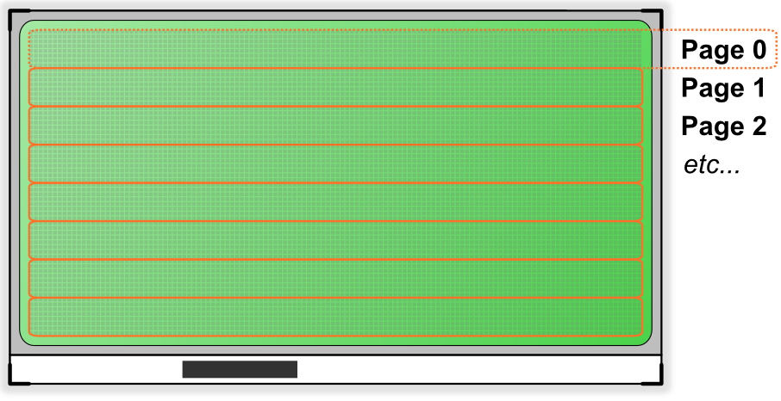

Screen Layout:

So, for our LCD Display, we have a single controller for the whole screen.

The on-chip controller for the LCD has display data RAM of 65x132 – 8580 bits with:

* RAM bit data “1”: a dot of display is illuminated
* RAM bit data “0”: a dot of display is not illuminated

To simplify, the 128x64 pixel screen is made up of 8 pages, each of which is 8 pixels high and 132 wide (as shown in image below). This maps nicely to the software buffer required for caching the screen contents because each page is a byte high.

**The top left of the screen is 0,0 and the bottom right is 127,63 pixel**. This makes some of the math required in software much easier. To write date at (0,0) it is necessary to select page 0, column 0 and then set the individual bit. Similarly, location (32,32) is in page 5. The simplest method of writing data to the screen is to send a whole page at a time, starting from the left in column 0 and continuing to right at column 127.

Sending a command to the screen:

Issuing a single command to the screen is the most basic building block of the interface code.

The steps require are:

* Set the A0 pin low to indicate that command data is being sent
* Set the chip select (CS) pin low
* Send each bit of the command, starting with the MSB and working down to LSB
* Set the chip select (CS) pin high, to free the bus

Therefore the “display on” command (which is 0xAF or 0b10101111) should be sent as :   
1, 0, 1, 0, 1, 1, 1, 1.

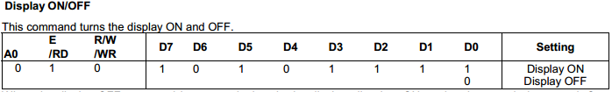   
As long as the SPI timings are not violated there is no need to introduce any delays as the screen will never be “busy”.

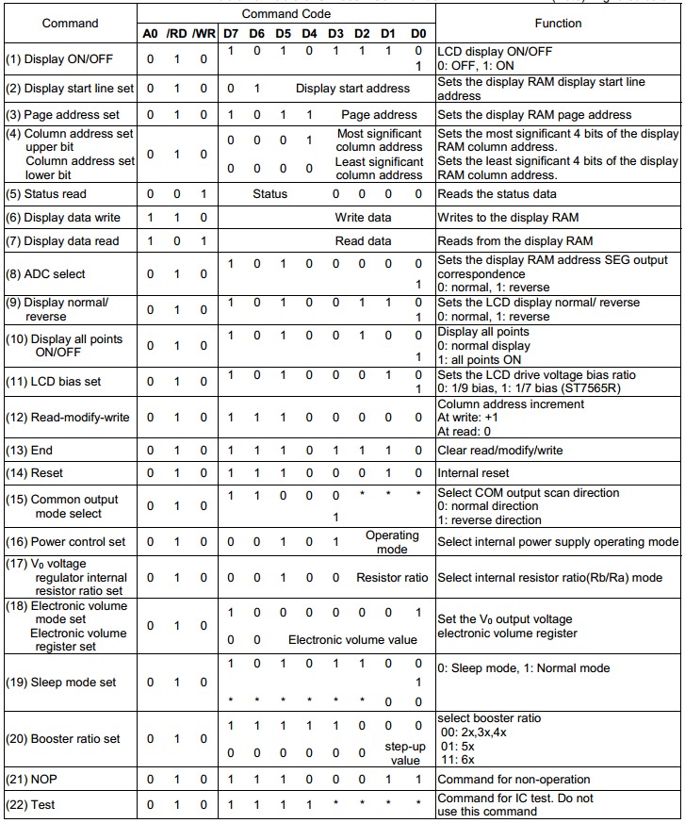

Table of LCD Commands

Screen Initialization:

Now that we can send a single command to LCD, we need to follow a number of steps to setup the screen.

* Strobe the RESET pin low then high, to initiate a hardware reset
* Setup the duty cycle (either 1/7 or 1/9) depending on the physical LCD
* Set the horizontal and vertical orientation to a known state
* Configure the internal resistor divider which is used by the voltage regulator
* Turn on the internal voltage booster to provide power to the LCD glass
* Initialize the dynamic contrast to a default value
* Reset the current display position to the top left

The commands for these are single bytes except the dynamic contrast, which is explained later. Below is an image captured from a logic analyzer while the initialization code runs.

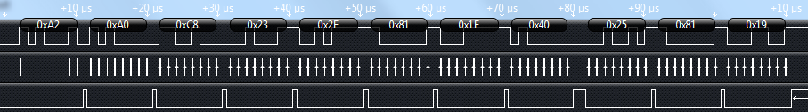

In this trace the following things can be seen:

* Command 0xA2: set the LCD bias to 1/9th
* Command 0xA0: horizontally “normal” (not flipped)
* Command 0xC8: vertically “flipped” (complements the command above)
* Command 0x23: the internal resistor divider set to 3 (from 0..7)
* Command 0x2F: power control, all internal blocks ON
* Command 0x81: enter dynamic contrast mode
* Data for the dynamic contrast mode, set to 31 (from 0..63)
* Command 0x40: go back to the top left of the display

When power is first applied to the screen it is also important to clear the onboard screen memory. As it is non-volatile RAM it will start in an unknown state.

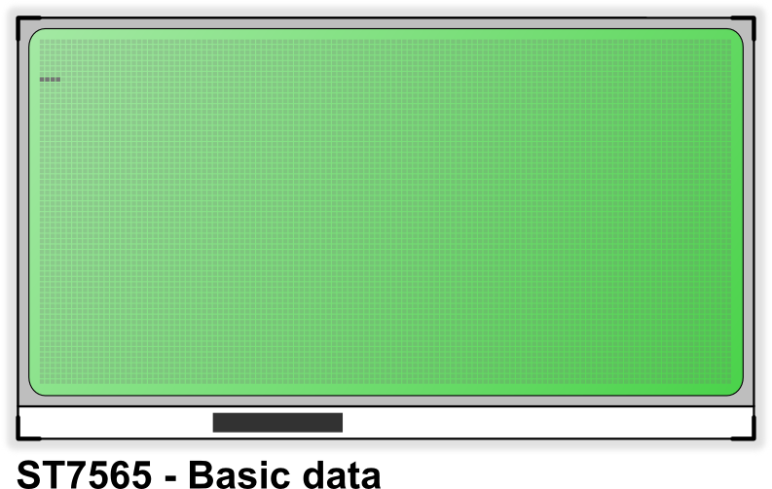

## Part 2:

Sending data to the screen:

The only difference between sending a command and data is the A0 pin.  When sending data the A0 pin must be high to differentiate the bus data from a command.

To start we send a command to reset the position to the top left corner (0,0). After this a quick trick is to write a single byte and see how it is displayed. It is important to know which way round the screen will display the data it receives, whether the “most significant bit” or “least significant bit” is displayed at the top.  The illustration below shows the output if the byte 0x80 is sent four times to the screen:

From this it can be seen that the most significant bit displays at the bottom of the page. The first bit we send is at the bottom, then subsequent bits work upwards toward the top of the page. This will be important later when we try to set an individual pixel.

Displaying a basic test pattern:

The easiest way to test if the driver code is working is to send a very basic test pattern. A quick check is to send constant bytes of 0xFF to fill the screen. If this works, then variations can be tried, such as 0xF0 or 0xAA.

At the end of each row, after every 128 bytes, it is necessary to select the next page and move to the start of the row.

Writing to specific pixels: The useful part for the lab

Writing specific pixels opens a whole world of possibilities from lines, circles, 1 bit-per-pixel graphics and variable height fonts. As these graphics functions are not dependent on a specific controller or screen it is best to split them out into a separate library which is portable across any screen.  This is perhaps the most difficult portion whilst developing a library to work with any screen.

In order to set a specific pixel it is necessary to break the process into a number of steps:

* Find the corresponding byte in the software buffer
* Calculate the bit within this byte
* Use logical OR (to set the bit) or AND (to clear the bit)

Finding the correct byte is straightforward.  The first position in our array is at the top left of the screen.  The 128th byte in the array (Array[127]) is on the first page at the right hand side of the screen.  The next bit “wraps” to the next page, at page 1 column 1.

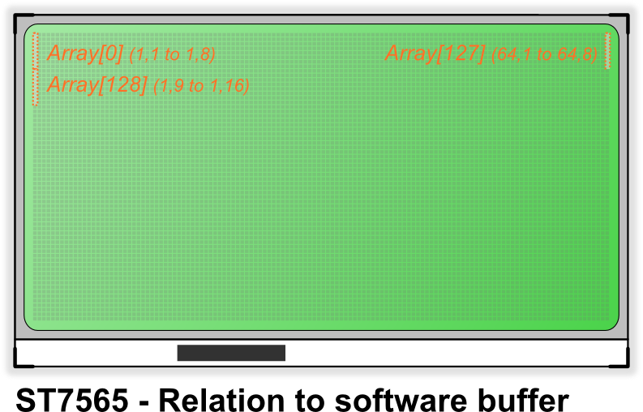

To calculate which byte we need to use we need to divide the Y position by 8 and multiple the result by 128.  To this we add the X position, then subtract 1 (as C arrays start from 0).  The equation $ X + ({ \frac{Y}{8} \times 128 }) - 1 $ works well in C.  To verify this is correct:

* (1,1) on the screen would give $ 1 + ( \frac{1}{8} \times 128 ) - 1 = 0 $
* (61,52) on the screen would give $ 61 + ( \frac{52}{8} \times 128 ) - 1 = 828 $

To calculate the bit inside this byte we must remember that the 8th (most significant) bit appears at the bottom of the page. So, to write to Y location 8 we need to set the 8th bit of a byte on the first page. To write to Y location 16 we need to write to the 8th bit of the corresponding byte on the second page. Therefore, we need the remainder after the Y position is divided by 8, which can be found using the modulo operator. This is as simple as Y % 8:

* (1,1) means setting 1 % 8 = the 1st bit
* (61,49) means setting 49 % 8 = the 1st bit
* (61,53) means setting 53 % 8 = the 5th bit

Displaying Text:

The LCD has no built-in font. The quickest and easiest way of displaying text on the screen is to define an 8-pixel high font. This maps directly to one page (or ‘line’) of the display and therefore we can use very fast instructions to copy the data from a predefined font to the right area of the screen. However, this limits us to a fixed height and only 8 line of the screen.   
  
With the knowledge that we can set a specific pixel it is easy to make advanced graphics functions.

## Part 3:

There are additional controls that can be used with the LCD:

Inverting the screen:

With a single command the LCD can be instructed to invert the display. This can be useful for emphasis or to make the screen easier to read in certain situations. The command “display normal or reverse “ is 0b1010011X, where X is 1 for reversed or 0 for normal.

Blacking the screen:

The LCD is capable of setting all points on the display to black without affecting the screen RAM.

Dynamic contrast control:

The contrast for the LCD used here is set by an internal resistor divider. This means that it can be set in software and altered dynamically. To change the contrast we need to send two commands. The first enters “volume mode set” and the second sets the contrast from 0 to 63.

The number of useful steps may be less than 64. Lower values are not visible as the voltage is too low, higher values make the screen completely black as there no distinction between pixels which are off or on. *This feature could be used with a light sensor to dim the screen depending on ambient conditions. It can also be used to fade the screen in or out.*

Improving efficiency:

Refreshing the screen involves sending the entire local buffer to the screen RAM. If only a few changes have been made then this is a very inefficient way to update the screen.

It would be possible to send each individual write to the screen, simply by copying the single byte that has changed each time a pixel is written. However this is inefficient if more than a single bit (or pixel) is set in the same byte in subsequent operations. Changes to the screen will also be very visible at slower speeds.

As the screen has 8 pages the most efficient method on ATmega328p is to send only the pages which have changed. Each time a pixel is set or cleared the corresponding page in the local buffer is marked as ‘dirty’. When it comes to refreshing the screen only the dirty pages are transferred.

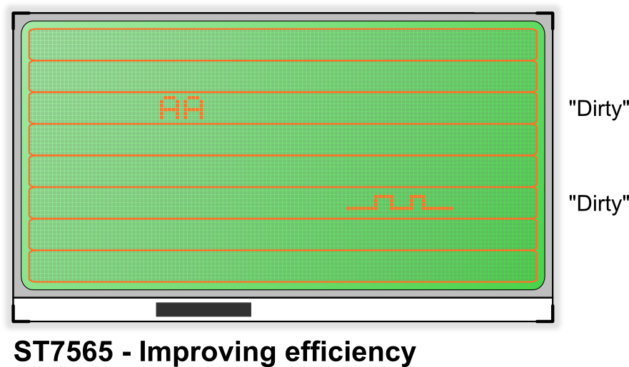

In the image above only pages 2 and 5 have had changes made. Therefore, these will be sent to the screen, which takes ¼ of the time as sending all 8 pages.

The screen could be subdivided into even smaller regions, for example 16 half pages. The trade-off of extra code each time a pixel is set and the reduced bus time sending data should be considered carefully.

**[Schedule and scoring]:**

At the end of this part, show the TAs that all the library functions for implementation are working.

**Part2: Touchscreen Interface and Calibration**

**[Objective]:** For the second part of the lab, we now interface Touchscreen with LCD circuit and read coordinates from the Touchscreen and then calibrate the Touchscreen input w.r.t. LCD display.

1. Interface the Touchscreen with Arduino UNO using ADC

2. Detect the Touchscreen by reading the ADC values and be able to record maximum and minimum coordinate values in X and Y directions.

3. Calibrate the Touchscreen w.r.t. LCD, showing that touching screen at a point in visible LCD region draws a pixel on LCD.

4. Verify that calibration is correct by drawing a pixel on LCD and then touch the screen at those points. The ADC values of x and y coordinates by the Touchscreen should map with the values of your algorithm to print a corresponding pixel on the LCD.

**Following link shows the desired output from this part :** <http://tinyurl.com/ponglab-touch>

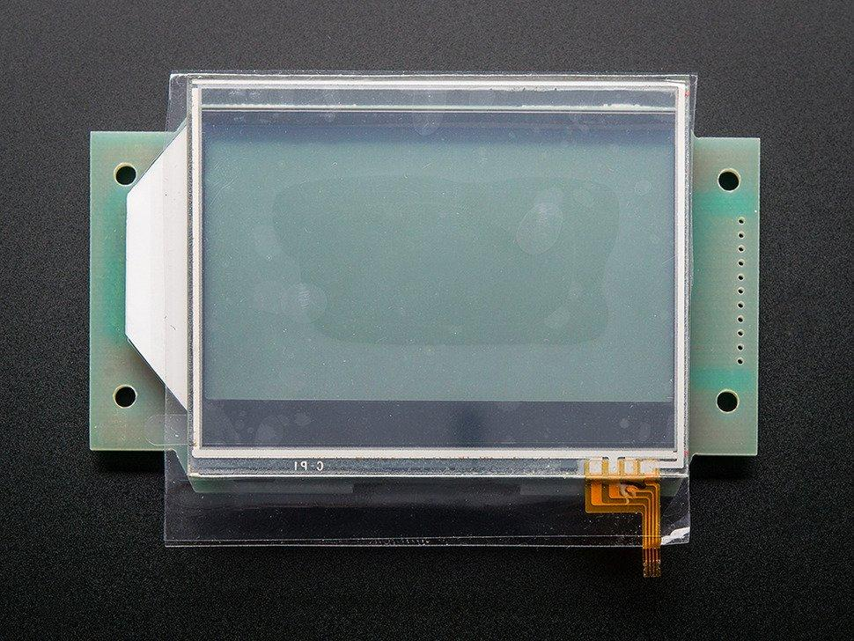

**LCD with serial interface LCD with touchscreen**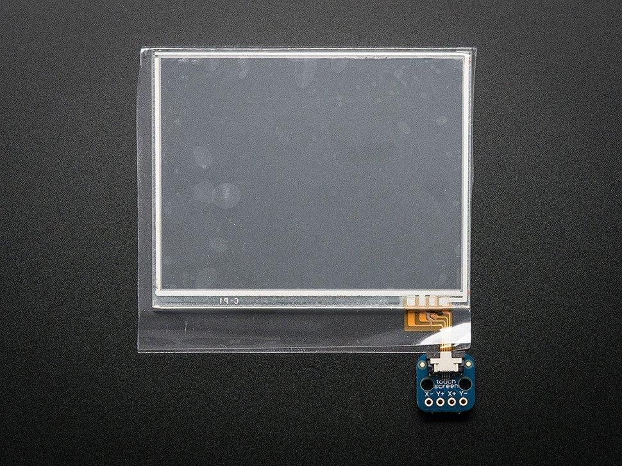

**[Deliverables]:**

1. At the end of this part you should have a properly interfaced Touchscreen over ADC to Arduino UNO.

2. The Touchscreen should be properly calibrated and display pixels on the LCD to corresponding touch in the visible LCD region.

**[Background]:**

The touchscreen used here is resistive which can be used with a stylus or fingertip and quite easy to interface with microcontrollers like ATmega328p. Due to simplicity of interface, it can be put on top of a LCD to make a DIY touch activate display, which is the main objective of this part of the lab.

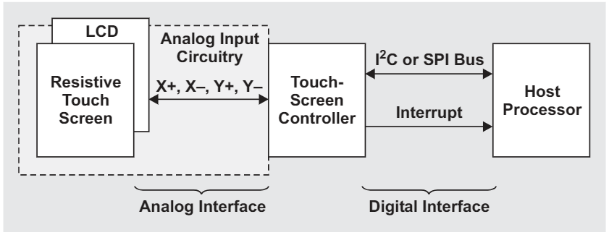

Typical four-wire resistive touch-screen system

The LCD has a 3.2” diagonal active area with a four wire resistive display coming out on a 0.5mm FPC connector. We will interface it with Atmega328p on four of its ADC pins, 2 will be analog input pins and 2 digital out at any instant. Touchscreen has 600 ohms resistance across X pins and 300 ohms across Y pins. We will see in the following section how these details are useful.

How analog resistive touch screens operate:

Usually a resistive touch screen consists of at least three layers: A flexible membrane made from PET film is suspended over a rigid substrate made from glass or acryl. Both surfaces are coated with a transparent conductive film like ITO (Indium tin oxide). The conductive ITO layers are kept apart by an insulting spacer along the edges, and by spacer dots on the inner surface of the two ITO layers. In this way there will be no electrical connection unless pressure is applied to the topsheet (PET film).

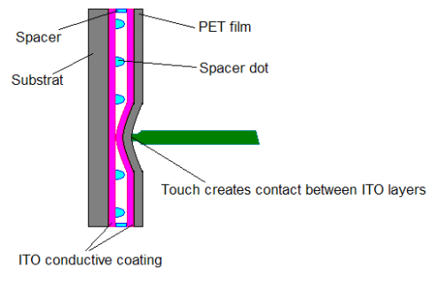

Resistive touch screens

4-wire touch screens use a single pair of electrodes (“Busbars”) on each ITO layer. The busbars in the topsheet and substrate are perpendicular to each other. The busbars are connected to the touch screen controller through a 4- wire flex cable. The 4 wires are referred as X+ (left), X- (right), Y+ (top) and Y- (bottom).

An advantage of the 4-wire touch screens is that it is possible to determine the touch pressure by measuring the contact resistance (RTouch) between the two ITO layers. RTouch decreases as the touch pressure (or the size of the depressed area) increases. This characteristic can be useful in applications in which it is not only required to detect where the pressure is applied, but also the type of pressure (area and force).

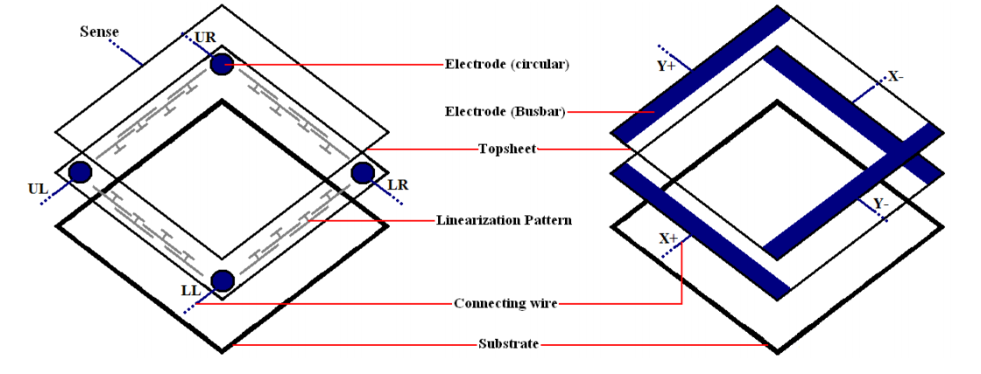

Electrodes in 4-wire(right) and 5-wire(left) touch screens

5-wire touch screens have circular electrodes (see Figure 2-2). Since all of them reside in the substrate ITO there is a need for linearization pattern (conductive) to make an applied voltage gradient uniform.   
4 wires connect to the electrodes these are referred to as UL (Upper Left), UR (Upper Right), LL (Lower Left), LR (Lower Right). The fifth wire is used for sensing the electrode voltage and is referred to as the “sense” wire. The sense wire is embedded in the topsheet. The advantage of the 5-wire touch screen type is that the ITO coating on the topsheet is not required to be perfect. This means that physical wearing of the 5-wire touch screens is less critical than for 4-wire touch screens.

Measuring touch point:

The method for measuring the pressure point is based upon a preferably homogenous resistive surface (ITO). When applying a voltage to the electrode pair in the resistive surface a uniform voltage gradient appears across the surface. A second ITO layer is necessary to do a high-resistance voltage measurement. A resistive touch screen can thus be seen as an electrical switch requiring a small amount of pressure (0.1 – 1.5 Newton) to close.

The point of contact “divides” each layer in a series resistor network with two resistors (see Figure 2-3), and a connecting resistor between the two layers. By measuring the voltage at this point the user gets information about the position of the contact point orthogonal to the voltage gradient. To get a complete set of coordinates, the voltage gradient must be applied once in vertical and then in horizontal direction: first a supply voltage must be applied to one layer and a measurement of the voltage across the other layer is performed, next the supply is instead connected to the other layer and the opposite layer voltage is measured. In stand-by mode one of the lines are connected to a level triggered interrupt in order to detect touch activity.

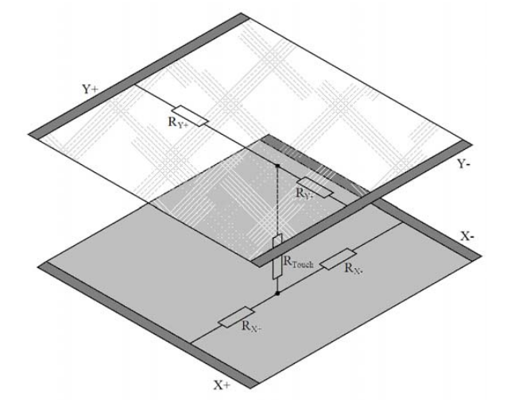

Schematic of a 4 wire touchscreen when pressure is applied

4-wire touch screens scanning

|  |  |  |  |  |
| --- | --- | --- | --- | --- |
|  | X+excite | X-excite | Y+excite | Y-excite |
| Standby | Gnd | Hi-Z | Hi-Z | Pull up/Int |
| X-coordinate, Z1 | Gnd | Vcc | Hi-Z | Hi-Z/ADC |
| Y-coordinate, Z2 | Hi-Z | Hi-Z/ADC | Gnd | VCC |

Compared to 4-wire, 5-wire touch screen only use the topsheet for measuring.

5-wire touch screens scanning

|  |  |  |  |  |  |
| --- | --- | --- | --- | --- | --- |
|  | ULexcite | URexcite | LLexcite | LRexcite | Sense |
| Standby | Gnd | Hi-Z | Hi-Z | Hi-Z | Pull up/Int |
| X-coordinate | Gnd | Vcc | Gnd | Vcc | Hi-Z/ ADC |
| Y-coordinate | Gnd | Gnd | Vcc | Vcc | Hi-Z/ ADC |

To get a complete set of coordinates, the voltage gradient is applied on the substrate layer once in horizontal direction to determine the Y coordinate and once in vertical direction to determine the X coordinate. In both cases the topsheet layer is used to do a high-impedance measurement after the sensing voltage has settled. In standby mode the fifth wire (sense) is connected to a level triggered interrupt in order to detect touch activity.

So essentially, we need 4 digital IO pins and two analog inputs (ADC) but since the pins on the Atmega328p can be configured as both analog input and digital IO, 4 pins are sufficient for a four wire touch screen controller.

So the two ADC input channels are connected to X- and Y- pins and the other two pins on the same port. Following on the scanning data from the table :

a. To read X coordinate first, we will put X- and X+ in digital mode and set X- high and X+ low.

b. Then we set Y- , Y+ to ADC input mode and read the Y- ADC value as X coordinate on Touchscreen.

c. Then we switch to read Y coordinate, for which we put Y- and Y+ to digital mode and set Y+ to low and Y- to high.

d. Finally , we set X- and X+ to ADC input mode and read the X- ADC value as Y coordinate on Touchscreen.

e. We continuously do above 4 steps in order to read for (x,y) coordinates on touchscreen.

Calibration:

We need to calibrate so as to translate the measured touch screen data into true screen coordinates of the LCD.

The generic algorithm has to compensate for scaling errors, offset and rotation of the touch screen coordinates relative to display coordinates. To eliminate these error factors, six calibration coefficients (A, B, C, D, E, F) are required. Converting touch screen coordinates (Xt and Yt) to display coordinates ( Xd and Yd) can be performed using equations below :

Xd = A(Xt) + B(Yt) + C

Yd = D(Xt) + E(Yt) + F

Three sample points (P1, P2, P3) are necessary to get the six calibration coefficient values. The sample points must be inserted in order to create a set of linear equations.

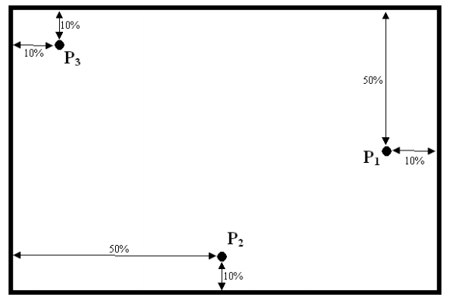

Xd1 = A(Xt1) + B(Yt1) + C

Yd1 = D(Xt1) + E(Yt1) + F

Xd2 = A(Xt2) + B(Yt2) + C

Yd2 = D(Xt2) + E(Yt2) + F

Xd3 = A(Xt3) + B(Yt3) + C

Yd3 = D(Xt3) + E(Yt3) + F

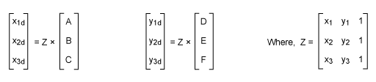

Solving these equations will give us values of A, B, C, D, E and F, but we will not need this generic equation for our calibration as it is time consuming and if Touchscreen and LCD have no rotation amongst them. This leads to a very simple algorithm for calculation.

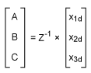 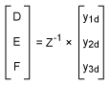   
where Z-1 is the inverse matrix of Z.

For our case, the touch screen controller (1024x1024, 10 bit ADC controller) and LCD display (128x64 pixels) do not have the same resolution, so simple scaling factors are needed to match their coordinates to each other. We will not need to use the equations derived before.

For example, consider a touch-screen system that uses an LCD with a resolution of 1024 (X coordinate) × 768 (Y coordinate) and the Texas Instruments TSC2005 touch-screen controller with 12-bit (4096 × 4096) resolution. The scaling factors to match them are kX = SX/S′X = 1024/4096 = 0.25 for the X-axis coordinate and kY= SY/S′Y= 768/4096 = 0.1875 for the Y-axis coordinate, where SX is the LCD’s X-axis resolution, S′X is the touch-screen controller’s X-axis resolution, SYis the LCD’s Y-axis resolution, and S′Y is the touch-screen controller’s Y-axis resolution. Thus, a touch-screen controller’s X coordinate, X′, should be understood by the LCD (the host) as X = kX × X′; and a touch-screen controller’s Y coordinate, Y′, should be understood by the LCD (the host) as Y = kY×Y′ .

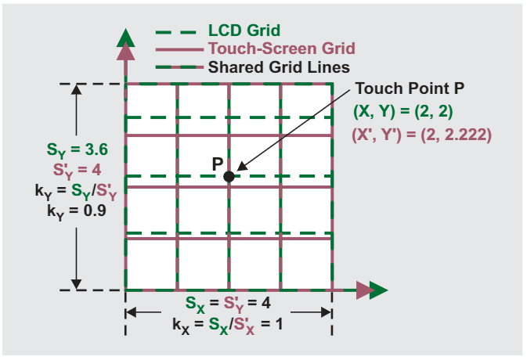

Scaling factors on the Y axes of LCD and Touch screen

**[Schedule and scoring]:**

This part should be complete at the end of the second week lab and shown to the T.A.s

# Part3: Pong Game

**[Objectives]:** Third section of the lab now builds up on the LCD and touchscreen interfaces to implement Pong game logic on Arduino Uno adhering to minimum requirements of the game as :

1. The game should satisfy the following criterion:

a. Two paddles along the Y axis on each edge. Paddle height of atleast 8 pixels and maximum 12 pixels. Width of 2 pixels is desirable.

b. Proper gridlines for the whole of visible LCD region.

c. Ball of maximum 3 pixel radius, preferably originating at the centre of the display

d. Score keeping for both players, can be reset after certain no of rounds

e. Paddles move in top or bottom direction when touched on screen. Keep in mind to have bounded region of input for each of the paddles.

f. Ball starts with a random direction and random speed, which can change with each round. Ball should follow proper game dynamics.

g. Change LCD color when a player loses to make it more fun-like.

h. Game resets when a player loses and scores reset after a certain no of rounds.

2. Interface Piezoelectric buzzer using PWM on Timer1(OC1A) and generate sounds in the game:

a. When ball hits horizontal surfaces

b. When ball hits the paddles

c. When ball misses the paddles

These are not the exhaustive limits of the game. You can implement more features of the game as long as you satisfy these.  
Refer to the Video here for an overview of game: <http://tinyurl.com/pong-lab>

**[Deliverables]:**

Show the T.A.s with a complete working game.

1. A working pong game in line with the requirements listed above.

2. Touch feedback functional for the paddle movements.

**[Background]:**

This part is where you get the LCD, touchscreen together with the Arduino Uno and implement a basic game logic to show that both LCD libraries written by you and the Touchscreen calibration work in harmony with each other.

A final setup of the game should look like this:

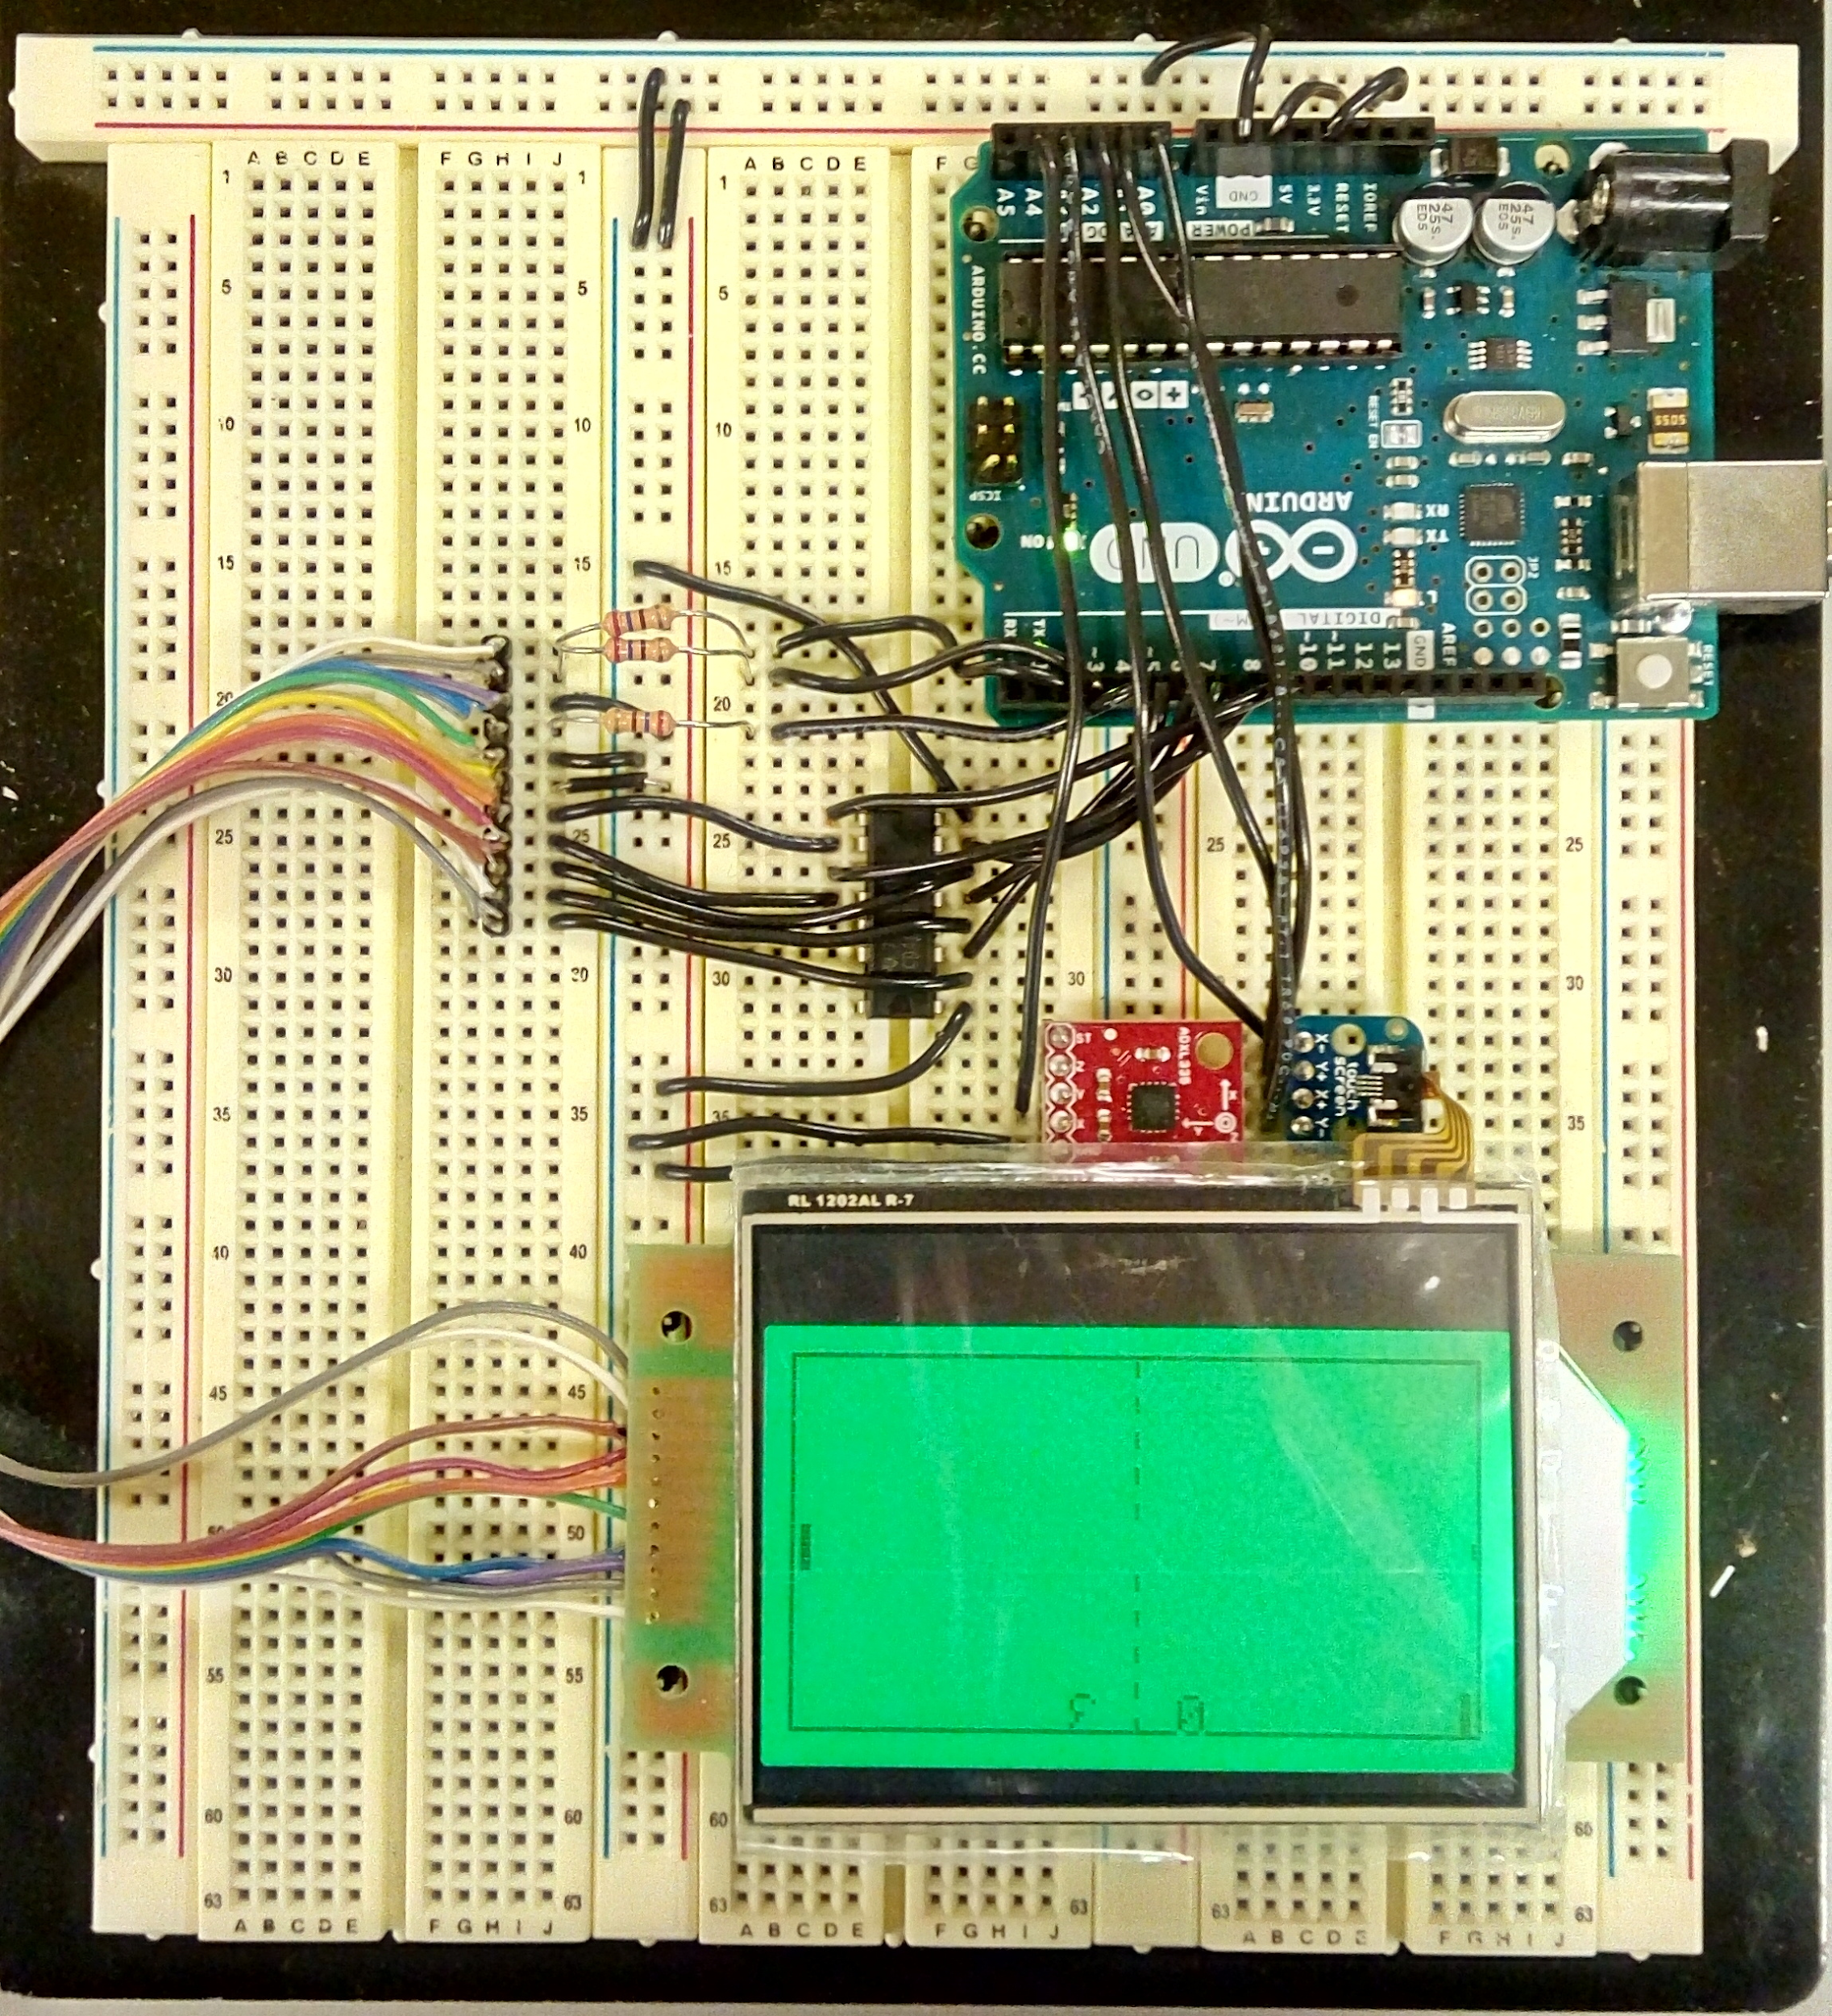

A simple breakdown of the game would be to:

a. Section of code which draws the game on the LCD

b. Section of code which checks for input for each of the paddle

c. Section of code which updates the paddle based on input

d. section of code handling the ball movement

e. Section of code which initializes the game on resets.

**[Schedule and scoring]:**

Show the T.A.s a working pong game setup as per the specified minimum requirements.

# Part4: Interface Accelerometer with Pong

**[Objective]:** The objective of this part of the lab is to now interface an accelerometer ADXL335 with the existing circuit and use the sensor readings along the paddle axis to control the movement of one of the paddles. The other paddle is a computer player now.

1. Interface ADXL335 accelerometer with the Arduino UNO and read the sensor readings.

2. Use the sensor output from the accelerometer to control one of the paddles

3. Complete the game by modifying the other paddle to play like a computer player.

**[Deliverables]:**

A complete working Pong game setup with LCD interface (SPI), Touchscreen ( ADC) and Accelerometer (ADC) with a computer player against a player controllable by touchscreen or Accelerometer.

**[Background]:**

So, far we have proper Pong game implemented with Touch screen input on a LCD display. For this part we intend to extend the features of the game by interfacing it with an accelerometer to get sensor inputs and use it have a AI player in the game.

We are using ADXL335 breakout board as an accelerometer. ADXL335 is a triple axis accelerometer i.e. it can measure acceleration along three axis viz x, y and z.

The ADXL3xx outputs the acceleration on each axis as an analog voltage between 0 and 5 volts and is interfaced with Arduino UNO over ADC.

Following is the pin connections for the breakout board :

|  |  |  |  |  |  |  |
| --- | --- | --- | --- | --- | --- | --- |
| Breakout board pin | Self-Test | Z-Axis | Y-Axis | X-Axis | Ground | VCC |
| Arduino Uno Pin | NC | NC | NC | A4 | GND | 3.3V |

How does the Accelerometer work?:

An **Accelerometer** is a device which can convert acceleration in any direction to its respective variable voltage. This is accomplished by using capacitors (refer image), as the Accelerometer moves, the capacitor present inside it, will also undergo changes (refer image) based on the movement, since the capacitance is varied, a variable voltage can also be obtained.

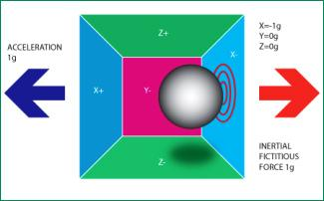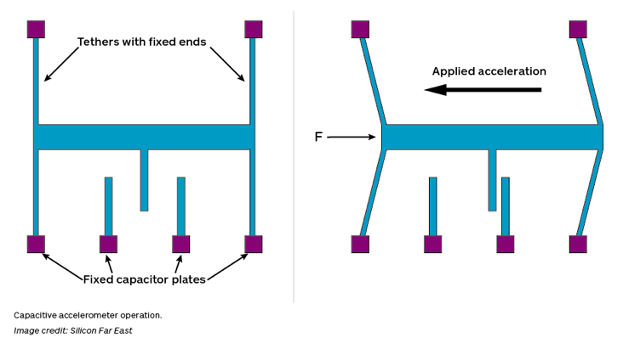

The ADXL335 sensor measures acceleration with the help of a layer of polysilicon suspended above silicon wafer with the help of polysilicon springs. The motion of this mass is translated into the motion of the plates of a differential capacitor and thereby providing an output proportional to acceleration. Every accelerometer suffers from the problem of gravity effect. No matter how accurate your sensor is calibrated (even your phone’s accelerometer), it will be affected by gravity.

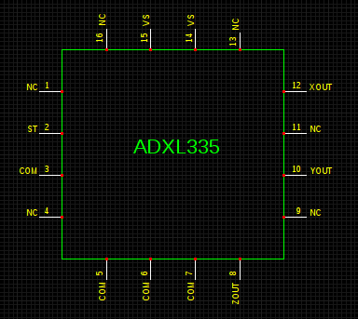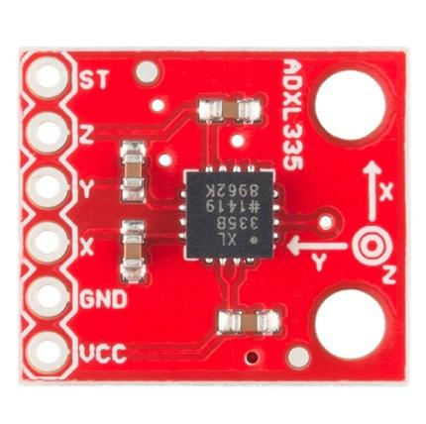

Pinout of ADXL335 Sensor

Interfacing ADXL335 with Arduino:

For this lab, we will use only X-axis output from the accelerometer. Therefore, connect VCC to 3.3V and GND to Ground. And then connect ‘X’ pin from the breakout board to A4 on Arduino Uno.

Reading raw values from Accelerometer:

As we saw before the accelerometer readings are affected by gravity. We can reduce the effect of gravity by using a Simple Filter. This filter will consist of two arrays, one is used to store the sample values from sensor and the other is used to sort the sample values, and find the most repeated value.

A simple algorithm to write this simple moving average filter would be :

1. Choose a sample size for the readings like 10. You can change the sample size depending on how random are the accelerometer readings.

2. Connect the accelerometer to Arduino and get readings from the ADC interface.

3. Pass the raw accelerometer readings to an array with the chosen sample size. Use this array with raw data to get an array with sorted readings. Then get an average value of this array. We add a new raw accelerometer reading to the raw data array in each iteration, while we calculate the average of the sorted array, hence moving average.

4. Find the maximum and minimum smoothed out readings along the x-axis of the accelerometer by tilting it far ends on each side, using the moving average filter.

5. We can then use the regular readings mapped to a byte( 0 to 255) between this maximum and minimum values from the filter for the accelerometer.

Use this simple algorithm to write a moving average filter function for the Accelerometer readings and then use the mapped out reading to control the position of the paddle in the Pong game similar to the touch interface previously.

**[Schedule and scoring]:**

This section should be completed at the end of two weeks and demo shown to the T.A.s at the beginning of next lab.

**[Final Submissions]: Due: April 5/6, 2018**

1. LCD driver code

2. Working Pong game code with touchscreen, LCD, buzzer and accelerometer integration.

3. Demo to the T.A.s for Prelab and each of the four parts.

4. Submit a report explaining how each of the tasks in each of the four parts of the lab and the prelab were completed. Do not forget to include pictures of your circuits. Push the game/project code to your respective GitHub repository.

